CS827 Project Report

Daniel Schroeder
Student # [redacted]
April 20, 2008
Abstract

Using the player’s voice as input, I have developed a video game called Daniel Schroeder’s Pitch Games which is a series of 2D mini-games where the player controls some aspect of the game with the pitch of their voice. In addition to using the pitch of the player’s voice as input, one of the mini-games also uses information read in from a MIDI file in real-time to control some of the game parameters. This report discusses some of the techniques used to create the mini-games, including how the pitch detection and MIDI parameter mapping are implemented, as well as some research information on different techniques that can be used to estimate pitch, and the type of MIDI information that can be useful to map to game parameters or events.

Introduction

Using a person’s voice as a method to control computer applications is nothing new. Speech recognition is currently a very active subject in the research community and there are many applications capable of responding to verbal commands from a user. Using the pitch of a person’s voice to control an application on the other hand has received much less attention. While using pitch to control a whole application is not very practical, it can be used to control one or two parameters of an application fairly effectively. This lends itself nicely to video games as it offers a new and innovative way for the player to interact with the game.

Video games have existed for many years now, but only fairly recently have new forms of input been experimented with and started to become mainstream. Examples of this include the popular video game “Guitar Hero” and Nintendo’s new console, the “Wii”. Using pitch estimation to allow a player to play a game using their voice is another type of interaction worth exploring.

In addition to using the pitch of a player’s voice as input to the game, we can also use other information such as midi data to control events which occur in the game in real-time. In a game controlled by the pitch of a player’s voice, using musical information to control game events could prove to be very interesting. One obvious application of this could be to have the player try to match the pitch of their voice to the given musical information, essentially making the player “sing” a particular song or melody.

I have developed a video game called Daniel Schroeder’s Pitch Games which consists of four mini-games where the player controls the game using the pitch of their voice. The game was created using C#, Windows Forms, the .NET framework (Requires at least .NET 2.0), and GDI+ for the graphics and code. PD (Pure Data) was also used to capture voice input from the microphone, extract the pitch from it, and for processing midi file information to make game events correspond to the midi events. OSC (Open Sound Control) was used to pass data between PD and the video game.

All images, referenced as Figure AX (where X is a number), may be found in the Appendix at the end of this report.

Background

Pitch detection has been a popular research area for many years and has many practical applications. Some of these applications include pitch correction for musicians, MIR (Music Information Retrieval), and resolving ambiguities in speech recognition. Even though pitch detection has been researched for many years, there are still problems with the current methods. For example, most of the pitch detection algorithms have problems accurately estimating the pitch when there are multiple pitches present in the input audio signal. Because of problems such as this, there is currently no best or perfect pitch detection algorithm, so a variety of methods exist. These methods include, but are not limited to, the Zero Crossing Rate, Auto-Correlation, the Yin Estimator, Harmonic Series Detection, Cepstral Analysis, and Maximum Likelihood.

Although pitch detection has been around for many years, only very recently has it begun to be applied as a form of input to video games. The most recent mainstream video game to incorporate pitch input is Harmonix’s “Rock Band”. In Rock Band the player must play a virtual instrument (guitar, drums, or microphone) and try and match their input as closely as possible to the song being played. The player using the microphone must try and mimic the singing which occurs in the song. The player is rated in real-time using pitch, rhythm, and phoneme detection.

Before Rock Band came out I could find only one other game which used the pitch of the player’s voice to control the game. This name of this game is Racing Pitch, and it was a finalist at both the 2006 MindTrek competition and the 2007 Independent Game Festival. Racing Pitch is a racing game where the player controls a racecar which is fixed to a track; so the player does not control steering the racecar. The only control the player has is by using the pitch of their voice. By mimicking the sound of a racecar engine, the player is able to make the racecar move. This is the only control over the racecar that the player has. The goal of the game is to complete the race tracks in the shortest time possible. The game incorporates a few extra features such as the car wiping out if the player takes a turn too fast, and blowing the racecars engine if they “rev it” at a high RPM for too long. These simple little additions, in addition to mimicking the sound of a racecar to make the car move, make Racing Pitch a very fun little game.

Controlling video games using a media such as music is another area of video games which only recently has begun to be explored. These types of games are called BMRGs (Background Music Reactive Games). Because midi files are very small and contain discrete note information, they are ideal for processing and easily lend themselves to be used to trigger and control video game events. There are currently many rhythm games such as “Parappa the Rapper” and “Guitar Hero” which require the player to trigger specific events (i.e. press specific buttons) at specifics moments which correspond with the music being played. These rhythm games typically are not truly BMRGs as the events and their timings are usually pre-programmed and read from a script file, not created by reading a media file at run-time. Only a few true BMRGs have been created, such as “AudioAsteriods”. AudioAsteroids is similar to the original Asteroids video game except that the creation of asteroids, enemies, items, and other game objects are determined at run-time according to the background music which is playing; so events occurring in the background music trigger the video game events.

Motivation

The reason I chose to create Daniel Schroeder’s Pitch Games is because there currently are not very many video games which focus on using the pitch of the player’s voice as a main form of interaction. After playing Racing Pitch and realizing how fun this type of interaction could be, I was eager to try and see what other type of interactions the pitch of a player’s voice could be used for. Also, I wanted the chance to try and map musical midi events to game events as this seemed like a very interesting and attractive idea. I decided to create a video game because creating video games is something that I enjoy, and I knew that it would be the perfect opportunity to explore both of these ideas.

The Project

As mentioned earlier my project is a video game which consists of four mini-games. In addition to the four mini-games, the project also includes a Profile Settings area and a High Scores area. The High Scores area (Figure A1) simply displays the Profile with the high score in each of the mini-games, as well as the current Profile’s individual high scores. The Profile Settings area (Figure A2) is used by the player to specify the pitch range of their voice. I implemented an auto-detect feature which records the player’s lowest and highest pitch as they sweep their voice from a low pitch to a high pitch. From there a Pitch Meter is shown and the player can adjust their low and high pitch values until they can comfortably move the Pitch Meter from the bottom to the top using the pitch of their voice. All pitch information used in the mini-games is then relative to low and high pitch values the player has specified in their Profile. This was an important feature to implement because most people’s voices have a different pitch range, so by using a dynamic pitch range it allows anybody to play the game comfortably.

The first mini-game is called Spong (Figure A3), which is short for Sound Pong. This mini-game is a simplified version of Pong in which the player plays against themselves (i.e. there is no other player). The player controls the paddle using the pitch of their voice. The paddle movement is relative to the middle pitch of the player’s pitch range. This means that if the player’s pitch is in the middle of the pitch range, the paddle will not move. If it is slightly higher than the middle pitch the paddle will move up slowly, and if it is greatly higher than the middle pitch the paddle will move up very quickly. Similarly if the player’s pitch is less than the middle pitch, the paddle will move down instead of up. The points for Spong are directly proportional to how long the player survives before losing all three balls.

The second mini-game is called Shooting Gallery (Figure A4) and is based on the shooting gallery games often found in carnivals where the player has to shoot at ducks using a BB or water gun. In this mini-game the player first selects the Tune (i.e. song) that they want to use to play the game. The game then loads the selected MIDI file and processes it for Note-On messages. When a Note-On message from the desired Channel is detected, the game creates a new duck target to float across the screen. Notes are only taken from one Channel so that all of the targets correspond to the same MIDI instrument. There are three rows which the ducks may travel across the screen in, and the row chosen for each duck is based on the Note (i.e. pitch) of the Note-On message, so low notes are placed in the bottom row, middle notes are placed in the middle row, and high notes are placed in the top row. The speed that the duck travels across the screen at is proportional to Note’s Velocity (i.e. amplitude). The ducks are then positioned so that they will cross the middle of the screen three seconds after the Note-On message was received, as the player is only able to “shoot” ducks when they are in the middle of the screen. Optionally I can then delay producing the sound of the MIDI events by three seconds to make the onscreen events occur at the same time the music event is heard. This option is turned off by default as it interferes with pitch detection, but can easily be turned on within the PD patch. The player earns points for every duck that they hit, but they also lose points every time they produce a pitch and do not hit a duck. The purpose of this is to try and make the player produce a melody with their voice, as opposed to just holding notes for a long period of time.

The third mini-game I produced is called Pitch Matcher (Figure A5). The objective of this game is very simple; the player tries to match their Pitch Meter to another Target Pitch Meter that is shown. The closer the player’s pitch is to the pitch on the Target Pitch Meter, the more points they earn. The Target Pitch Meter randomly changes the target pitch at different speeds so that the player has to constantly adjust the pitch of their voice to match the target pitch.

The last mini-game I produced is called Target Practice (Figure A6). This mini-game uses both the pitch of the player’s voice, as well as its amplitude. In this game the player is shown a target on the right side of the screen, and a bow and arrow on the left. The purpose of the game is to fire an arrow and hit the target. The player controls the angle of the bow and arrow using the pitch of their voice, and controls the power of the shot (i.e. how fast the arrow goes) using the amplitude of their voice. The amplitude of the player’s voice is shown in a power meter. Each time the player hits the target, the target is randomly moved to a new location along the right side of the screen. The goal of this mini-game is to try and hit the target as many times in a row as possible.

Procedure

To detect the pitch of the player’s voice my video game uses PD. I created a patch in PD which captures audio input from a microphone and uses the fiddle~ object to detect the pitch of the player’s voice. The player’s pitch is represented as a midi note which has a value between 0 and 128; the pitch range of my voice on this scale ranges from about 45 to 65. In addition to the player’s pitch, the fiddle~ object also outputs the amplitude of the player’s voice in the microphone. To help avoid erroneous pitch detection, the fiddle~ object is told to only process the pitch of a sound signal if it’s amplitude is over a certain threshold; 70dB is the threshold I used. This helps prevent false pitch detections by ignoring much of the background noise. Furthermore, the cooked pitch output of the fiddle~ object is used over the raw pitch output. This also helps prevent false pitch detections because in order for a raw pitch value to be considered a cooked pitch, an incoming audio signal must maintain a raw pitch value which does not deviate more than a half-tone from the average raw pitch over the span of 30ms. The fiddle~ object also outputs when an Attack occurs, which is when the onset of a new sound is detected such as at the beginning of speaking a new word. However the Attack detection was not consistent enough to actually be useful for my purposes.

Once this information has been obtained from the fiddle~ object it is passed into the video game through the use of OSC (Open Sound Control). OSC allows PD to connect with my video game over a UPD port so that data may be exchanged between the two applications. Once this information is received by the video game it is then used as input to control a part of the game in some way. Three of the four mini-games only make use of the pitch value, but the Target Practice mini-game uses both the pitch of the player’s voice as well as it’s amplitude as inputs.

One of the four mini-games, Shooting Gallery, also uses MIDI files which are read-in in real-time to control game events. In order to correlate game events with music (i.e. MIDI events), the game first opens the MIDI file in a Windows Media Player control which is embedded into the video game. Rather than outputting the MIDI sound to the speakers, the data is instead outputted on the LoopBe1 Virtual MIDI port which has been previously installed. PD is then setup to receive MIDI messages through the LoopB1 Virtual MIDI port, so the MIDI information goes straight from the embedded Windows Media Player into PD. The PD patch then extracts the MIDI Notes (i.e. pitches), along with their Velocity (i.e. amplitude) and the Channel they should be played on. This information is then passed onto the video game using OSC, similarly to how the pitch information is passed into the video game. I analyzed other MIDI information such as Control and Program (i.e. Instrument) Change messages, Pitch-bend, and Polyphonic Key Pressure to see if they might be useful to use, but their values did not fluctuate enough on the midi files I was using to make them of interest to me.

Once the Note, Velocity, and Channel are passed into the video game, it then parses this data looking for relevant information. If any relevant information is found, it then triggers the appropriate game event. For the Shooting Gallery mini-game, relevant data included Notes that were on a specific Channel and had a Velocity greater than zero (i.e. were not Note-Off messages). The video game then generates the new duck target and specifies that the duck should be in the middle of the screen three seconds after the MIDI information was received. A toggle in the PD patch may be flipped on manually to output the MIDI data to the speakers. After sending the information to the video game, the patch sends the information through a pipe for 3 seconds so that when the sound plays it will correspond to the events happening on screen in the game. However this option is disabled by default as outputting music and sounds interferes with the pitch detection.

Research and Development

As mentioned earlier, there are several techniques which may be used to estimate the pitch of an audio signal. It has also been stated that noise in the input audio signal, as well as multiple voices in the audio signal introduce extra complexity into the pitch detection process. For this discussion, assume that the input audio signal is clean (i.e. no extra noise) and that only one person is speaking into the microphone.

Before we can look at pitch detection techniques, we must first understand what pitch is. When we refer to the pitch of an audio signal, we are actually referring to the fundamental frequency of the audio signal. The goal of pitch detection then is to accurately estimate the fundamental frequency of an audio signal, which is usually the lowest frequency component, or partial, in which relates best to the other partials in the signal. “In a periodic waveform, most partials are harmonically related, meaning that the frequency of most of the partials are related to the frequency of the lowest partial by a small whole-number ratio” [1]. This lowest partial would then be considered the fundamental frequency of the signal, or the pitch of the signal.

The Zero Crossing Rate (ZCR) algorithm attempts to detect the fundamental frequency of an audio signal in the time-domain by watching how many times the audio signal crosses zero in a given time frame. At first it was assumed that the number of times the signal crossed zero would be related to the number of times the waveform repeated per time unit. This would give the periodicity of the waveform, which is inversely proportional to the frequency of the waveform. However it soon became apparent that this technique did not work well for many types of audio signals. Signals with most spectral energy focused around the fundamental frequency would cross zero twice per cycle (Figure 1a), while signals with much higher-energy spectral content would cross zero more than twice per cycle (Figure 1b). Figures 1a and 1b are taken from [1].
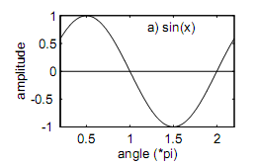
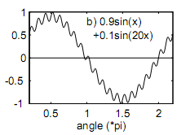
Figure 1a Figure 1b

A simple way around this problem is to use the Peak Rate instead of the ZCR. Instead of looking at how many times the waveform crosses zero, the Peak Rate looks at how many times the local maxima of the waveform is reached per second. This tells us how often the waveform repeats per second (i.e. the periodicity of the waveform), which can be used to give us the frequency of the waveform, or in other words, the pitch.

Autocorrelation is another time-domain technique used to try and estimate the pitch of an audio signal by finding the periodicity of the waveform. The Autocorrelation technique works by sampling a copy of the waveform at different time frames, t_{c}, and measuring its “similarity” to the original waveform at a fixed time, t_{o}. When t_{c} = t_{o} the waveforms should be identical and their similarity measure should be at a maximum. As t_{c} progresses in time away from t_{o} the similarity measure will decrease until it reaches a local minimum at the point of half of the period of the waveform. As t_{c} continues to progress in time, the similarity measure should begin to increase, again reaching the maximum similarity at the point of the period of the waveform. This is because this is the point where the waveform begins to repeat. This can give us the periodicity of the waveform, again whose inverse is equal to the frequency of the waveform. One problem with this approach is that it assumes the waveform is not pseudo-periodic; that is it assumes that the waveform at time t_{o} is unique and should only occur again at time t_{o+p} which is equal to time t_{o} + the length of the waveform period. However it is possible that the waveform at t_{o} is identical (or very similar) to the waveform at a time between t_{o} and t_{o+p}, which may result in the detection of a false period, giving the wrong periodicity of the waveform.

As mentioned above, pitched signals are typically composed of a set of harmonics, or partials, where the lowest of these partials is the fundamental frequency of the signal. There are several techniques which transform the signal into the frequency-domain and then to try and identify these partials to extract the fundamental frequency. One such technique is the Optimal Comb Filter algorithm. I believe that this is the technique used by PD’s fiddle~ object, and as such is the technique used in my video game. This technique works by first transforming the audio signal into the frequency domain, typically using the Fast Fourier Transform. From here a comb filter may be applied, where the “fingers” of the comb are equally spaced and correspond to a fundamental frequency and its harmonics (i.e. partials). For example, if the chosen fundamental frequency was 50Hz, the comb would have “fingers” at 50Hz, 100Hz, 150Hz, 200Hz, and so on. When the comb filter is applied to the original signal, only the partials of the original signal which fall on the “fingers” of the comb are passed through; all other frequencies are removed. Multiple comb filters may then be applied to the original signal and the comb filter which allows the most partials through will correspond to the fundamental frequency of the signal. This technique works well as long as many harmonics of the fundamental frequency exist in the original signal. If the signal contains only one partial for the fundamental frequency this technique will fail as multiple comb filters may let more partials through than the true fundamental frequency comb filter. If the signal contains multiple pitches, this technique can be repeated after removing the first fundamental frequency and its harmonics to determine the fundamental frequency of the second pitch. One problem with detecting multiple pitches this way is that the second pitch found may be incorrect if removing the first pitch and its harmonics from the signal removes many of the second pitches harmonics, such as if the first pitch removed was 100Hz and the second one is 50Hz (since they will have many overlapping partials).

The Harmonic Product Spectrum (HPS) is another technique that operates on the same idea as the Optimal Comb Filter technique, but is implemented differently. Because the harmonics of the fundamental frequency occur at integer multiples of the fundamental frequency, dividing the frequency spectrum by integer x (i.e. down-sampling) should place the x^{th} harmonic at the same position in the spectrum as the fundamental frequency. The process for this would be first to divide the original spectrum by 2 and store the result, then to divide the original spectrum by 3 and store the result, and so on. This should result in 2nd harmonic being placed at the position of the fundamental frequency when divided by 2, the 3rd harmonic being placed at the position of the fundament frequency when divided by 3, and so on. From there, multiplying original signal and all of the down-sampled signals should result in a signal with one clear peak, representing the fundamental frequency of the signal. This process is shown in Figure 2, which was taken from [3].

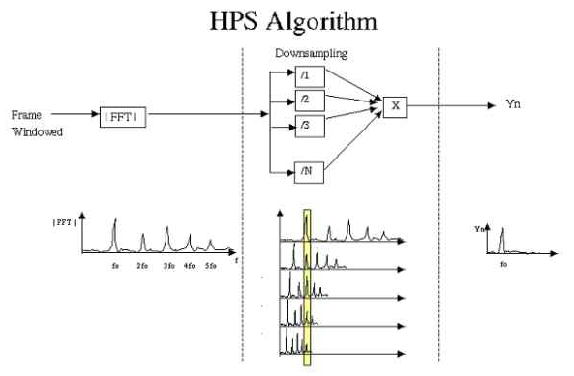
Figure 2

In addition to pitch detection, there has also been research done in the area of controlling video games with musical content, mainly by Jukka Holm. In [2] Holm notes three types of MIDI parameters which are optimal for use in video games. The first are Event Parameters, which are things such as Note-On messages. The game could simply perform an action whenever one of these messages is received, or it could base its actions on the Note (i.e. pitch) or Velocity of the note, or messages which come in only on certain Channels. This is the technique used in the mini-game Shooting Gallery to generate duck targets and to determine their position and speed. The second type of MIDI parameter which could be used to control video games is State Parameters. This would include things such as the songs tempo or the average polyphony (i.e. number of notes played) within a given time window. This information could be mapped to the games speed or other events. The last MIDI parameter that he mentions are Transition Parameters, such as when a song goes from being very soft and quiet to being very loud and aggressive very quickly. He notes that like Event Parameters, Transition Parameters are well suited to perform noticeable on-screen events.

Results

The results of my project are a fun set of mini-games which the player controls using the pitch of their voice. The video game must be played in a fairly quiet environment in order to avoid false pitch detections, and for the same reason loud sounds or music should not be produced by the game while the player is playing. Given more time, this is one problem I would have liked to try to overcome so that the games could have music while playing them. This would be especially useful for the Shooting Gallery mini-game, since the game events are driven by MIDI events and the relation between the music and game-play would have been very noticeable. It should also be noted that while the game may be fun for the player, it can be annoying for observers or people in the same location as the player as they will have to listen to the player make unusual noises for a lengthy period of time. While my mini-games are not particularly useful for vocal training, it is easy to see how the idea could be extended to help musicians control the pitch of their voice.

With respect to controlling video games using MIDI data, I have discovered that finding the right media for a specific purpose can be challenging. For example, all of the MIDI songs I downloaded had too many Note-On messages to be used in my Shooting Gallery mini-game, even when only processing Note-On messages from a specific Channel; the screen would be flooded with duck targets and the point of the game (trying to have the player produce a specific melody) was lost. In the end I had to create my own MIDI music using a trial version of FL Studio so that there would not be too many Note-On messages in a given time frame. Even then the Note-On messages had to be well spaced out (at least half a second between notes) to get the player to sing the melody correctly. If multiple notes occur very quickly after one another, it is easier to hit all the targets by simply holding a note instead of producing many short, quick sounds directly after one another. I was hoping to compensate for this by checking the Attack which is outputted by fiddle~, as this would help tell if the player actually spoke a new sound, or if they were just holding a note. Unfortunately fiddle~’s Attack output was not consistent enough to be used in this way. This means that only very simple, slow melodies can be achieved at the moment with Shooting Gallery. I was hoping to achieve better results in getting the player to sing a specific melody, but with the current design of Shooting Gallery it is hard to recognize even moderately complex melodies because there are only three different pitches of notes (i.e. three rows that the target ducks are placed in). Even though Shooting Gallery did not produce the result I was hoping for, it still shows that MIDI can be used to drive game-play and it is still a fine addition to the video game (if you just try and hit the target ducks and don’t worry about trying to sing a melody). I would have liked to experiment more with using MIDI information to control games, but I have run out of time to do that for this project.

Progress Report

Tasks accomplished:
- Implement passing data between PD and C# using OSC
- Get pitch detection with PD object fiddle~ working
- Perform tests with pitch detection using multiple voices, both boys and girls
- Research and perform tests on how to extract note information from a MIDI file using PD
- Write video game code to use pitch as an input
- Write mini-game framework to easily add new mini-games
- Research pitch detection and how to perform it
- Create and download graphics and sounds
- Write code to have MIDI events trigger game events
- Code the mini-games
- Test mini-games for bugs

Tasks that would be done next:
- Create more and better graphics, sound effects, and MIDI files for the mini-games
- Create more mini-games
- Integrate audio and MIDI processing into the video game so that it is not dependent on PD or LoopBe Virtual MIDI port

Conclusion

In conclusion, I have created a video game in C#, using PD for the pitch detection and MIDI message processing, which consists of four mini-games which the player controls using the pitch of their voice. I have accomplished what I set out to do for this project, and I am pleased with the results. Given more time I would like to polish up the existing mini-games and create additional mini-games, as well as look for a way to perform the audio and MIDI processing directly in my application, instead of having to rely on PD and LoopBe1 Virtual MIDI port to be installed before hand.

References

1. Gerhard, David. Pitch Extraction and Fundamental Frequency: History and Current Techniques. November 2003.

2. Holm et al. (2006). Using MIDI To Modify Video Game Content. NIME 06 Conference Proceedings, 65-70.

3. Middleton, Gareth. Pitch Detection Algorithms. http://cnx.org/content/m11714/latest/. 2003.

4. Rock Band. http://www.rockband.com. 2007.

5. Secret Exit. Racing Pitch. http://secretexit.com/games/racingpitch. 2006.

Appendix

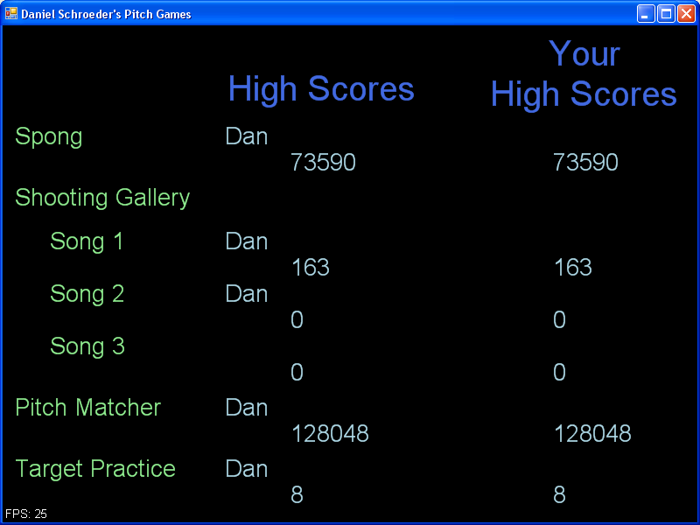
Figure A1

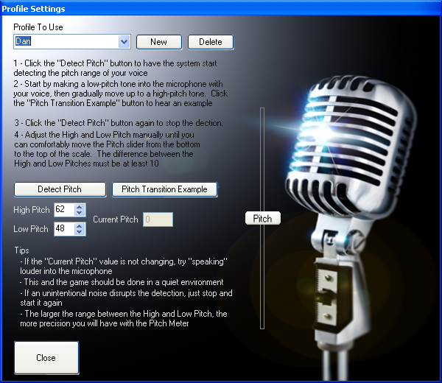
Figure A2

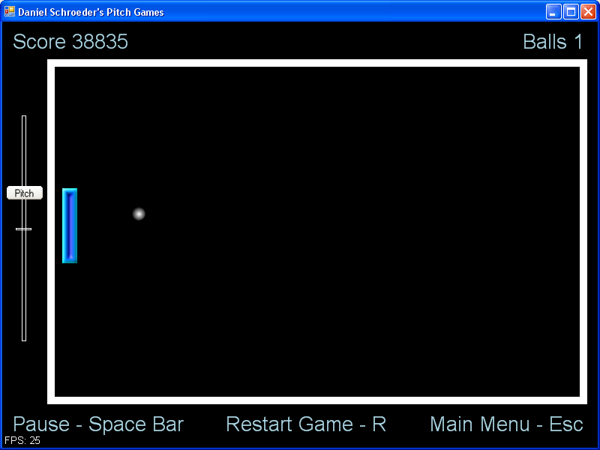
Figure A3

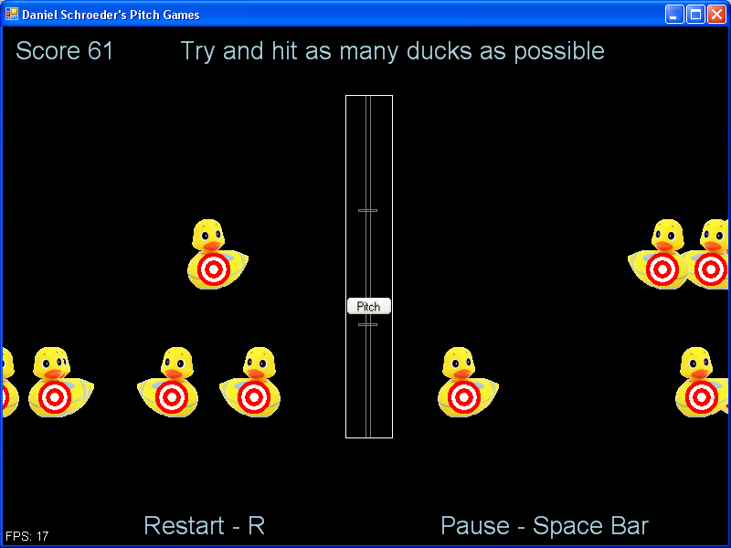
Figure A4

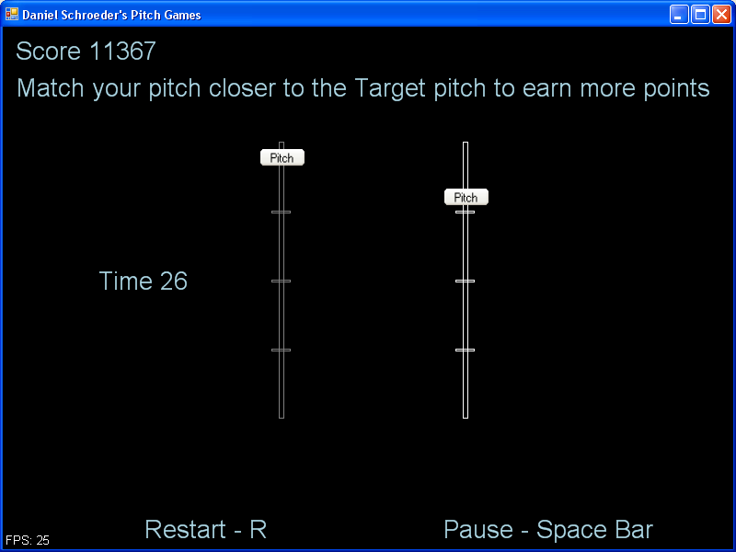
Figure A5

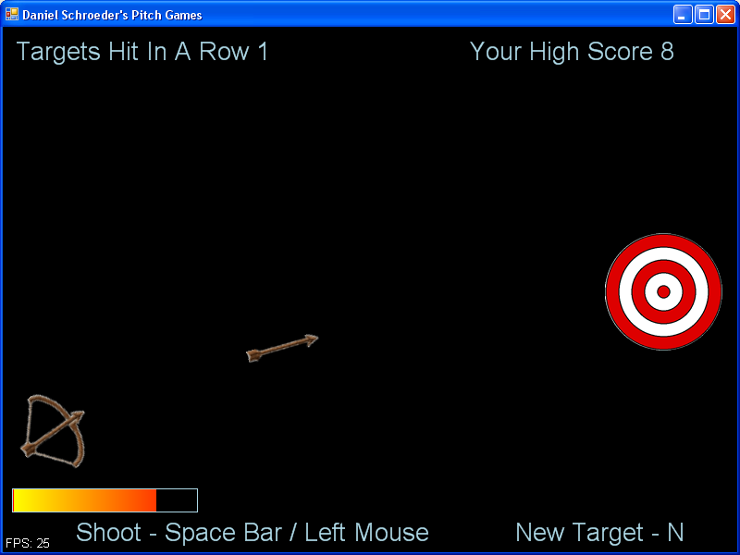
Figure A6

